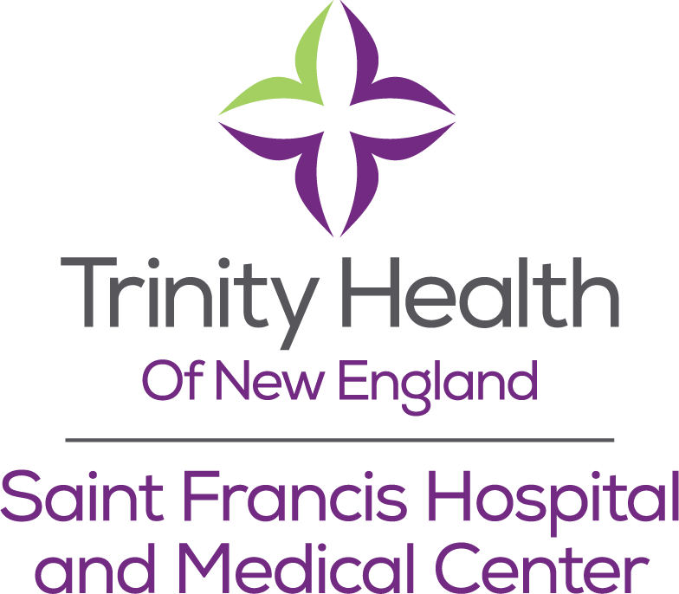

Surgery Service Line
Surgery Research Fellowship

Program Summary
The Surgery Research Fellowship at Saint Francis Hospital & Medical Center—a part of Trinity Health Of New England—features a two-year experience in surgical-oriented research. The program can accommodate two fellows, in succession, including first-year and second-year fellows (designated F1 and F2). The Research Fellowship targets interested and available surgical residents in any specialty, and is intended to be a two-year experience. This duration will include multiple research projects endeavored with any of several principal investigators. Research Fellows will work on local, regional, and even national and multi-center projects. Topics include:
Surgical Outcomes & Quality
Trauma Outcomes & Quality
Neurological Injury and Neurocritical Care
Colorectal Surgery
Surgical Oncology
Vascular Surgery Outcomes & Quality
Peri-procedural assessments & outcomes
Critical Care Sedation, Analgesia, Restraints, Ventilatory Care, Post-Intensive Care Syndrome
Opportunities in surgical subspecialties
Additionally, Enhanced Recovery programs; Sedation/Analgesia in the ICU; Falls; Interpersonal Violence; Coagulopathies and brain injury trauma; outcomes after TBI; others.
Resources
Dedicated Surgery Department Research Coordinator
CITI Program Biostatistics Courses
Our Surgical faculty are involved in regional- and national-level work with:
American College of Surgeons (ACS)
ACS Committee on Trauma
ACS National Surgical Quality Improvement Program
ACS Trauma Quality Improvement Program
Connecticut Surgical Quality Collaborative

Society of Critical Care Medicine
Chest Wall Injury Society
Capitol Area Shooting Task Force
Smilow Cancer Center at Saint Francis
New England Vascular Collaborative
Hospital and System-based research administration with dedicated Institutional Review Board and Research Integrity Committee.
In addition, Trinity Health is an integrated system of more than 90 hospitals, offering the possibility of system-wide funding for research in addition to multicenter trials.
Engaged physician & surgeon faculty with appointments at University of Connecticut School of Medicine and the Frank L. Netter School of Medicine at Quinnipiac University.
More than 1500 square feet of simulation studio, state of the art monitoring software and high fidelity trainer.
Extramural and intramural funding sources with >$1.3 million in support over the last five years.
Eligibility
Candidates for the fellowship will have:
- Completed a doctorate in medicine at an ACGME accredited university; considerations may be available for successful graduates of foreign medical schools.
- Successfully completion and passage of USMLE Step 1 and Step 2 exams; Step 3 scores highly considered. ABSITE scors will also be utilized to assess scholarship.
- Current categorical residency in an accredited general surgery or surgical specialty program. For residents in preliminary positions, consideration will be made under special circumstances.
- Maintained excellent standing in their residency program during the period of participation.
- A commitment to two years in the research fellowship.
Ideal candidates will have an aptitude for research, experience in clinical research, chart review, electronic health records, and the scientific process. Candidates with experience in manuscript preparation, grant writing, and advanced degrees in basic science or clinical applied science will be given special attention. Exceptional interpersonal skills will also be expected. Candidates will work alongside attending surgeons, research coordinators, institutional review board members, and staff from the hospital research administration.
Timeline
Application process begins January 1
Application deadline February 20
Interviews (in-person or tele-) January 1-March 15
Notification to candidates Before March 20th
Starting date: July 1 (year 1)
Completion date: June 25th-June 28th (year 2)
Employment Details

All fellows will be required to sign a contract with the hospital, and maintain eligibility within that program standard.

The Fellows will be compensated as appropriate for their PGY level, and benefits are described by the hospital system. Reimbursement will be reimbursed by Saint Francis Hospital & Medical Center for the research program duration. Travel and academic meeting benefits will be determined as needed by both the successes and by the Saint Francis Hospital & Medical Center Department of Surgery leadership.

Educational Requirements & Opportunities
- Prerequisites
  - CITI Program Training
    - Every fellow must complete CITI Program Training prior to their start date. The program provides education on research integrity, proper technique, consent, and more. If you have already been certified, please send your profile to the program, and you will be notified of anything outstanding. Completion date is anticipated by May 30th.
  - Biostatistics
    - You are invited to take the “fundamentals of biostatistics” online through the CITI Course as well, but payment must be arranged with the fellowship. Please inquire with the fellowship and we will make arrangements.
    - The goal is to complete statistical coursework before July 30th.
  - Reading
    - “Advanced Concepts in Surgical Research” (Bhandari & Robioneck, 2012). The book will be provided to you by the fellowship.
- Concurrent Education
  - Attendance at the Research Council Meetings is required
  - Attendance and facilitation of the Monthly Surgery Research Meeting is required
  - F1 will present the research matrix monthly, and will present at SFH Annual Research day
  - F2 will engage in a research education topic quarterly, to be presented in a 15 minute discussion at the department research meeting in August, November, February, and May.
- Other educational opportunities may present themselves. Formal education in the form of Master-level preparation must be discussed with the Research Fellowship director prior to any commitment.

Application
First Name M.I. Last Name

Date of Birth Email Address:

Home Phone: Mobile:

Current Address:

City: State: Zip Code:

Citizenship:

Current Residency: Program Director:

Program Director Contact Telephone: Email:

Program Coordinator Contact Telephone Email:

USMLE Step 1 Score USMLE Step 2/3 Score

List of References: (Include name, title, email, and phone number)

1.
2.
3.

Please attach:
- Photocopy of USMLE scores
- Current updated Curriculum Vitae
- A letter of good standing from your current residency program director
- A writing sample of 500-800 words on one of these topics: a research interest, a critique of a current surgical research topic, or an experience as a resident that changed your interest in research experience.
- Two letters of recommendation from current affiliated faculty
- Best days of the week or times of day for a video interview

Contact:
David S. Shapiro, MD, MHCM, FACS, FCCM, Vice Chairman, Surgery; Chief Quality Officer
860.833.5673 or dshapiro@trinityhealthofne.org

