

Policy Title: Days Off Policy  General Surgery | Effective Date: 01 March, 2024

Division(s) Policy is Applicable to:  ☒ St. Mary’s Hospital (ACGME #080458)  - Internal Medicine – (ACGME #1400813530)  ☒ General Surgery – (ACGME #4400831065) | To be reviewed every three years by:  Program Director of General Surgery

DEFINITIONS:
ACGME – Accreditation Council for Graduate Medical Education; ABS – American Board of Surgery; PGY – Post Graduate Year; PTO – Paid Time Off; WD – Wellness Day; Academic Year – July 1st through June 30th
PURPOSE: To standardize our policy on vacation days, wellness days, sick leave and schedule changes and absence for educational conferences. For clarity of language between this policy, the ACGME and ABS, the term PTO will be used to represent any and all non-clinical time as counted in the context of the minimum requirements for General Surgery Board Eligibility.

SCOPE:
We understand that throughout residency, residents will require days off due to illness, interviews and/or personal issues. Each resident must account for all days off from training as required by the ACGME and the ABS. The following policy explains the process that must be followed for these circumstances. The attached form must be completed, under all circumstances, and presented to the program leadership (coordinator). Once the program leadership receives the request, we (the Program Director, Program Coordinator, and the Associate Program Director) will coordinate with the Chief Residents for clinical appropriateness. Approvals for the day off and/or schedule change are not approved until the request form is signed and returned to the requesting resident physician. The requesting party should refrain from making travel arrangements or purchases until approval is received. The program will not alter decisions based on the requestors potential financial losses if they are required to alter or cancel plans that were made prematurely.

BLACK OUT DATES:
No vacation or time-off requests will be permitted, accepted, or approved for the last two (2) weeks of January, the last two (2) weeks of June, and the first two (2) weeks of July.

PROCEDURE:
As per the resident physicians’ employment agreement, each resident physician in the general surgery training program has up to twenty-one (21) days or three (3) weeks of paid time off (PTO). PGY1 preliminary residents, PGY2 preliminary resident, and PGY5 chief residents will only be permitted fourteen (14) days of voluntary PTO for their respective academic year. The remaining seven (7) days will be used as terminal leave for the last week of June of that academic year to account for moving to a fellowship program or new residency program. Any request for time off that is greater the seven (7) consecutive days requires the preapproval of the Program Director prior to submission of the request to program leadership and chief residents. No vacation request will encompass more than one calendar weekend. The standard seven (7) day vacation will be from Monday to the following Sunday. The 21 days or three weeks of PTO available to the residents account for all allowable non-clinical time during their training. This PTO covers: vacations, time-off, sick time and educational conference attendance where the resident is NOT presenting or receiving and award/prize. If a resident is presenting at or receiving an award from an educational conference, there will be a single travel day and the day of the conference participation allowed (up to two (2) per academic year) that are outside of the PTO system. Any additional days of “required” attendance will be counted as PTO and subtracted from the total for the year. Any PTO usage over that allotted will put the individual resident’s Board eligibility at risk upon completion of training and the accreditation of the training program by not having the requisite minimum 48 clinical weeks per training year.
The responsibility and burden of tracking and accounting for all training time, clinical and non-clinical, remains on the resident physicians throughout the course of their residency in order to remain board eligible upon completion of their training. As per the ABS certifying eligibility requirements the applicant for board certification with the ABS must complete “At least 48 weeks of full-time clinical activity in each residency year, regardless of the amount of operative experience obtained. The 48 weeks may be averaged.” Reference the following site for the ABS update leave policies: General Surgery Leave Policy - American Board of Surgery (absurgery.org)
The ACGME has a provision (as of 01 July 2022) wherein the Sponsoring Institutions must “provide residents/fellows with a minimum of six weeks of approved medical, parental, and caregiver leave(s) of absence for qualifying reasons that are consistent with applicable laws at least once and at any time during an ACGME-accredited program, starting the day the resident/fellow is required to report.” They must also “provide residents/fellows with at least the equivalent of 100 percent of their salary for the first six weeks of the first approved medical, parental, or caregiver leave(s) of absence taken.” Note that the requirement does not mandate vacation or sick days be used. It does, however, state that the minimum of six weeks of leave must be paid time off and that at least one week of paid time off must be reserved for use outside of these six weeks. Section IV.H. of the ACGME Institutional Requirements details specifics with regards to vacation time and leaves of absence. While all residents are entitled to this leave, it may require an extension of your training to remain Board Eligible. The program will work with the resident to adjust the schedule, as possible, to minimize the need for coverage and extension of residency. All residents must provide 30 days advance notice to program administration, as well as Human Resources, when leave is “foreseeable”. At that time, the resident will complete all necessary paperwork and follow the specific Procedure for FMLA and Leaves outlined by Human Resources on the HR4U site: https://hr4u.trinity-health.org/.

All PTO or vacation requests must be received by the program leadership no less than thirty (30) days prior to the requested time off. Any request that is received with less than thirty (30) days notice will not be considered. If you require time off where only short notice is possible, you must find another resident within the training program to swap shifts with. This request to swap call shifts must also be documented on the required and attached document or online form. All shift or call swaps will require the signatures (or email/text verification) of both residents before the request will be considered for approval by the program leadership.
In the event of an emergency request for time off (sick or dying family), every effort will be made to accommodate the needs of the requestor and make alterations to the call schedule. Depending on PTO already taken and PTO still planned, the resident may be required to forfeit days of their future scheduled PTO to stay within their contracted PTO days to remain Board Eligible upon completion of their training.
In addition to the resident’s PTO, four (4) wellness days are also available to use at a maximum of one (1) per calendar quarter. Wellness dates chosen by the resident are subject to approval at the discretion of the training program. The quarters are identified as: July through September, October through December, January through March, and April through June. Wellness days cannot be saved or accumulated to create additional “vacation” time. These are issued on an as requested basis only and will not be built into the residents’ schedules by default.

Any wellness day request must be submitted on the same (attached) document or online form and presented to the program leadership no less than fourteen (14) days prior to the date being requested. The program leadership will confer with the chief residents for suitability based on the current workload in the clinical environments. Once all members (program leadership and chief residents) agree, the form will be signed and returned to you unless requested online. In which case your will receive and email indicating the status of your request. Your request is not approved until you receive documentation (digital or paper) from the program leadership that indicates approval.

APPROVALS:
In an effort to be as “fair” as possible, time-off requests will be approved based on seniority (PGY level) and then by the date and time the request was submitted. Categorical residents will not receive preferential consideration over preliminary residents.

RESPONSIBLE DEPARTMENT: Surgery
RELATED PROCEDURES AND OTHER MATERIALS:

ACGME one-time leave policy, HR4U policies for CTFMLA & FMLA

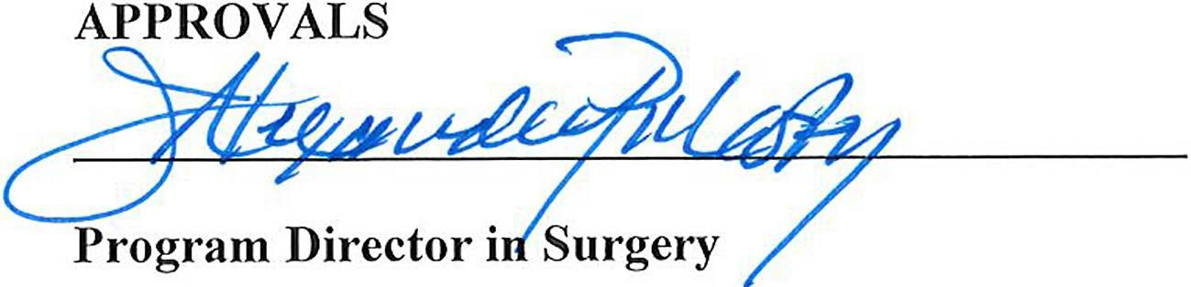
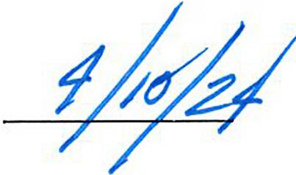

Initial Approval: 10 April 2024
Subsequent Review/Revision(s): 2027 / 2030 / 2033

Exhibit 1: PTO request forms
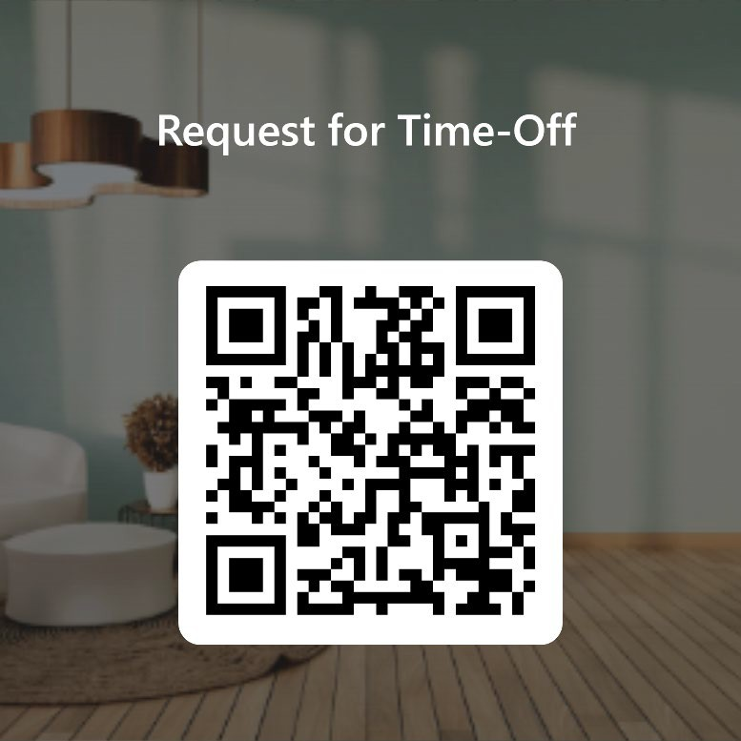
Link: https://forms.office.com/r/NSMYgD2A0F QR Code:

Paper form (if desire) attached on following page.

Saint Mary's
IHOIIIWI.

Tim,e off and Schedule Change R.equest Form
General Surgery ll,esldent Tralnlmg P111gram
fr>TW£iliiDns, r1If/js1J/f, wellness, amfmru:es, de...
.,.l. ,Saint Mary's Hospital
' TmtyH

L-as:t Name:

All time off requests must be submitted!to the Residency Leadership (via email at Ga.ryRodge@T rinityHealthOfNE..ovg or m person to Gary Hodge) at least 30 days prior to the requested time off for consid!erat:ion.
-.i'

-! �
� �
�"'
t �
r�
.-.t�
.-_;.; eI.
r-.::=::\
Any time off request that is less tha& 30 days in advance; yo11must find someone to swap shifts with you within the same calendar month. Shift swap agreements must be signed by both residents. Only sbi�t swaps will be entertained. This is in ordler to maintain proper adherence to all ACGME Work R-nles.
Shift Swap: Naro:ies: scheduled call proposed call

Si�ature: Resident /fl Signature: R.esid,ent »2

Program acknowledgment.of receipt of request:. Date: �---�IInitials�I-�
Approved D
Denied D Reason·

Signature:

Date:

